**LIBRARY**

**APA 7th Edition Handout**

**W**hat is APA?

APA stands for American Psychological Association and is an academic and professional writing citation guide. APA is generally used by writers or students of the Social Sciences: Psychology, Linguistics, Sociology, and Business.

**W**hy use APA?

APA writing provides clarity, consistency, and credibility to one's writing. Allows readers to focus on your ideas and easily find the relevant information supporting your ideas.

**A**PA General Guidelines.

* **APA papers have four sections**: title page, abstract, body, and reference page.
* **The student title page:** should include the paper title, student name, affiliation (School or institution), course number and titles, course instructor, and due date.
* **Recommended fonts:** 12 pt Times New Roman, 11 pt Calibri, Arial, Georgia, 10 pt. Lucida, Sans Unicode, and Computer Modern.
* **Margin-** 1-inch margin on all sides of a letter-size paper (8.5 X 11 inch).
* **Running header:** APA updated 7th edition does not require a running header.
* **Page numbering:** The page number should be on the upper right hand and half an inch from the top of the page on all pages. The title page should be numbered as page 1.
* **Title:** The title of each APA section should be centered and bold. It should not be in all “caps”.
* **Pronouns: “They or them”** is suggested to provide gender neutrality.
* **Spacing after sentences:** Double spacing throughout andonly a single space after the ending punctuation.
* **In-text citation:** sources with 3 or more authorsshould be shortened with **“et al”** after the first name.
* **Citing books:** publisher location is no longer required. Also, the e-book format should not be mentioned.
* **DOI numbers:** should be formatted like **“URL”.**
* **URLs:** the preface **“Retrieved from”** is no longer used.
* **Numerals:** Numbers under **“10”** should be spelled out and **“10”** and above should be expressed numerically.



Page Number

Title: **Centered, Bold**

Author’s Information: Centered, Double-Spaced, includes Name, University, Course, Faculty, Date

**I**n-Text Citations

* Personal communication such as emails, text messages, online chats or direct messages, personal interviews, telephone conversations, live speeches, unrecorded classroom lectures, memos, letters, messages from nonarchival discussion groups or online bulletin boards are considered as works with a non-recoverable source and should only have an in-text citation.

**E.g., Parenthetical in-text citation** (N. Bradley, personal communication, November 14, 2023)

* Cite sources directly or indirectly that have influenced your paper.
* In-text citations should consist of the author's last name and the year of the work.

**E.g.** (Bradley, 2023) or Bradley (2023) offered….

* APA prioritizes paraphrasing over direct quotation. Paraphrasing can condense and synthesize ideas/information from multiple sources.
* For direct quotations you should include the location of the quote by including page(s), and paragraph number in the in-text citation. The abbreviation “**p**” is used for a single page, and “**pp**” is used for multiple pages. For paragraphs use the abbreviation “**para**”. For audio and video files include a time stamp.

**E.g.,** Effective teams can be difficult to describe because “high performance along one domain does not translate to high performance along another” (Ervin et al., 2018, p.470).

**E.g.,** (OCD-UK, 2019, 4:50).

* Direct block quotes of 40-plus words should not be in quotation marks instead they should start on a new line indented .5 of an inch from the left margin. The author’s parenthetical reference should then appear after the final punctuation.

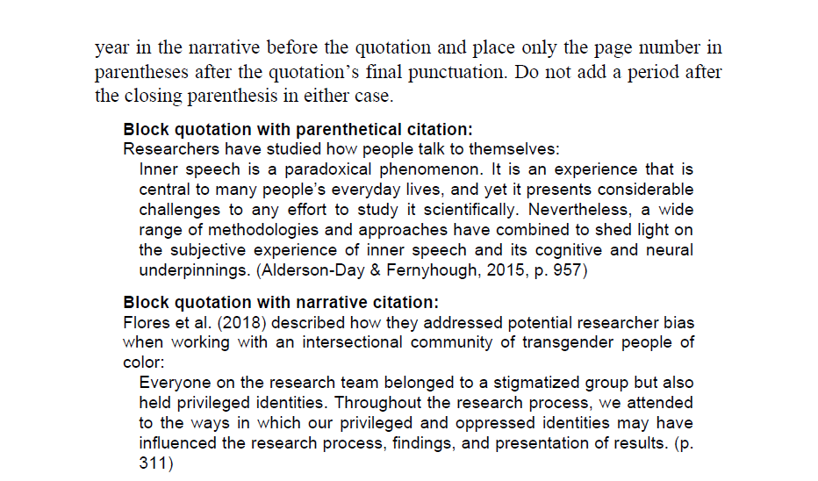

**E.g., Block Citations**

* For in-text citations of a work with two authors use both surnames and the year.

**E.g., (Narrative in-text citation)** Jones and Kim (2019) reported that …..

**E.g., (Parenthetical in-text citation)** (Jones & Kim, 2019).

* In-text citations with three or more authors use the first author's surname followed by “et al.” in every citation including the first.

**E.g., (Narrative in-text citation)** Jones et al. (2019) found that the effects of …..

**E.g., (Parenthetical in-text citation)** (Jones et al, 2019).

* When citing sources with unknown authors, use the work's title with the year of publication.

**E.g., a book with no author** (Interpersonal Skills, 2019).

* If the article or work is listed as “Anonymous” then anonymous is used as the author’s name in in-text and reference citations.

**R**eferences

* Reference citation has four basic elements: author, date, title, and source.
* Author refers to the person(s) or group responsible for the work. This can also be an organization, editor(s), film director, photographer, grant investor, or talk show/podcast host.
* If the author(s) is a person, the name should be inverted where the surname comes first followed by a comma “**,**” with the initials of the first name in upper case letter.

**E.g.,** Bradley, N. A.

* When citing work(s) with no author you should use the work's title. However, if the work(s) is credited as “**anonymous**” then “**anonymous**” is used as the author.

**E.g.,** Anonymous. (2017). *Instructions for the Virginia colony*. Great Neck Publishing.

**Title**

**Year**

**Publisher**

**Author**

* If a reference does not have a date the abbreviation “n.d.” should be used.

**E.g.,** The National Museum of Australia. (n.d.). The fight for civil rights. <https://indigenousrights.net.au/civil_rights>

* You should not italicize work(s) that are a part of a greater work such as journal/newspaper articles, or edited book chapter(s). The title should follow the sentence capitalization rule, which is only the first letter of the first word should be capitalized unless the word is a one-letter word that should be capitalized.
* Stand-alone titles such as books, report(s), webpage(s), and website(s) should be italicized and should follow the sentence capitalization rule.

**E.g.,** Golden, A. R., Griffin, C. B., Metzger, I. W., & Cooper, S. M. (2018). School

racial climate and academic outcomes in African American adolescents: The

protective role of peers. Journal of Black Psychology, *44(1)*, 47–73.

https://doi.org/10.1177/0095798A417736685

* For book(s), and report(s) that have edition, volume number, and report number these additional elements should be included in the reference citation in parentheses.

**E.g.,** Nursing: A concept-based approach to learning (2nd ed., Vol. 1). Note no punctuation mark is between the end of the title and the first parenthesis.

* For periodicals such as journals(s), newspaper(s) and magazine(s) the volume number should be italicized.
* Works without title you should add a brief description in square brackets.

**E.g.,** [Map showing the population density of the United States as of the year 2010].

* The reference list should be in alphabetical order and each reference should follow the “hangman style indentation”.
* The source of the work(s) refers to the location where the work can be retrieved from. For a book, the source would be the publisher. For periodical sources such as journals, newspapers, and or blogs you should include the periodical title, volume number or issues number, and page(s). If the article has a DOI or URL that should be included also.

**E.g.,** Judge, T. A., & Kammeyer-Mueller, J. D. (2012). “General and specific

measures in organizational behavior research: Considerations,

examples, and recommendations for researchers”. Journal of

Organizational Behavior, 33(2), 161–174. <https://doi.org/10.1002/job.764>

**Book:**

Author, A. A. (Year of publication). *Title of work: Capital letter also for subtitle*. Publisher.

**Journal Article:**

Author, A. A. (Year of publication). Title of article. Title of Journal, *volume number* (issue number), page range. DOI or URL

**Website:**

Author, A. A. (Year, Month Day of publication). Title of the webpage. Website name. URL

**Newspaper Article:**

Author, A. A. (Year, Month Day of publication). Title of article. Title of Newspaper, page range. URL

**Magazine Article:**

Author, A. A. (Year, Month of publication). Title of article. Title of Magazine, *volume number* (issue number), page range. URL

UB LIBRARY APA 7TH Ed. CHECKLIST

**GENERAL FORMATTING**

* Set the font to a “readable font type” such as 12 pt Times New Roman, 11 pt Calibri, Arial, Georgia, 10 pt. Lucida, Sans Unicode, and Computer Modern.
* **Margins** should be 1 inch all around.
* Your entire paper should be Double-space, with one space after the final punctuation of each sentence.
* The title of each page should be centered & bolded, and should not be in all “caps”.
* The beginning of each paragraph should be **Indented by** **½”** from the left margin, except for the abstract paragraph.

**HEADER**

* Set the page number on all page(s) including the “cover pager” **flush** **left** at the top of your first page.
* A running header is no longer needed for APA writing.
* On the cover page the **title of your paper** should be centered**.** You should not italicize, underline, or bold your title. Also, do not place it in quotation marks or all upper-case letters. Followed by **the instructor’s name, course name** **and** **number,** **and** **due** **date.** The due date should be in the day-month-year format. E.g., 8 May 2016. On separate lines.

**CITATIONS**

* You should cite the author’s name (in-text) in a parenthetical or narrative citation. E.g., Parenthetical citation **(Last** **name,** **year)**.
* You will need to include the location information if you are quoting not paraphrasing a specific part of a work, such as a page number, timestamp, or line number.
* You will also place quotation marks **before** and **after** every direct quotation, except block quotes.
* You should **indent** **an extra ½” from** **the** **left** **margin** for block quotes, which are direct quotes exceeding 4 lines of prose or lines.

**REFERENCE PAGE**

* Center the title, “Reference,” and bold.
* Your entries should follow the APA template of core elements – which are facts common to most sources like author, title, publication date, etc.
* Each citation in the (reference page) should be in **hanging** **indent** **½” from the left margin.**
* Remember to italicize book(s) and reports, capitalize only the first word of the title and subtitle, and use sentence case for the rest of the title.
* Italicize volume numbers for journals, newspapers, and magazines.
* Your references should be in **alphabetical format** **by** **author’s last name**, **title,** **or** **description** **beginning** **the** **entry**.
* If there is no DOI, provide the URL of the article.
* Titles are given in the entry in full exactly as they are found in the source. If the work does not have a title, include a description in place of a title.